**Project Design Phase-II**

**Technology Stack (Architecture & Stack)**

|  |  |
| --- | --- |
| Date | 03 October 2022 |
| Team ID | PNT2022TMID40746 |
| Project Name | Project – News tracker application |
| Maximum Marks | 4 Marks |

**Technical Architecture:**

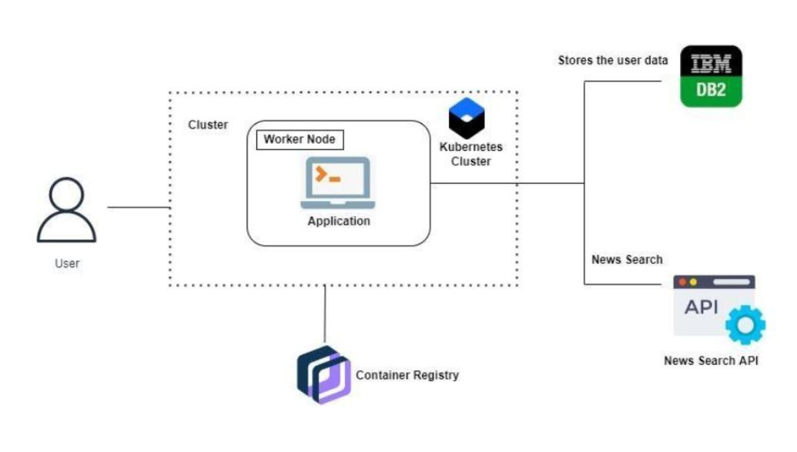

**Table-1 : Components & Technologies:**

|  |  |  |  |
| --- | --- | --- | --- |
| **S.No** | **Component** | **Description** | **Technology** |
|  | User Interface | Front end - Web UI, Mobile App. | HTML, CSS, JavaScript ,React Js,Flutter. |
|  | Application Logic-1 | Backend | Python Flask. |
|  | Application Logic-2 | Used to customer service. | IBM Watson Assistant |
|  | Database | Database service. | MySQL. |
|  | Cloud Database | Stores user data. | IBM DB2. |
|  | External API-1 | Search the news | Google news API |
|  | External API-2 | Search the news | Newscatcher API. |
|  | Machine Learning Model | Pushing the news based on preference | Object Recognition Model. |
|  | Infrastructure (Server / Cloud) | Application Deployment | Cloud registry, Kubernetes,IBM cloud. |

**Table-2: Application Characteristics**

| **S.No** | **Characteristics** | **Description** | **Technology** |
| --- | --- | --- | --- |
|  | Open-Source Frameworks | List the open-source frameworks used | Technology of Opensource framework |
|  | Security Implementations | List all the security / access controls implemented, use of firewalls etc. | e.g. SHA-256, Encryptions, IAM Controls, OWASP etc. |
|  | Scalable Architecture | Justify the scalability of architecture (3 – tier, Micro-services) | Technology used |
|  | Availability | Justify the availability of application (e.g. use of load balancers, distributed servers etc.) | Technology used |
|  | Performance | Design consideration for the performance of the application (number of requests per sec, use of Cache, use of CDN’s) etc. | Technology used |